Team ReLU: Computer Facial Emotion Recognition

Jun Ma, Kevin Gordon, Siqi Yan, Taylor Bos

# Introduction…

Computer emotion detection is an important milestone in realizing seamless human computer interaction. For our project, we propose a convolutional neural network approach to detect human faces and emotion. Building upon the successes of *The C231 Course Project* "Facial Emotion Recognition in Real Time" by Dan Duncan, Gautam Shine, and Chris English, we intend to improve the overall accuracy of the classifier and, if resources permit, improve the classifier speed performance. The C231 Course Project had a training accuracy of 90.7% and a test accuracy of 57.1% with a frame rate of approximately 2.5fps. Using a desktop webcam as an input, the classifier will detect subject faces, classify subject emotion and finally superimpose the corresponding emoji on the face.

# What is interesting…

The prevalence of face detection in popular culture has grown tremendously in the past year alone. Social media applications, especially those that are image and video based, give examples of both the applications of such technologies and user willingness to engage with computers through visual mediums. Examples include Snapchat’s 'Lenses' which overlays the user’s face with various masks, iPhoto's automatic person tagging which finds known subjects in a photo and tags them. While these examples give us an idea of the potential of such technologies, they are rudimentary compared to the human to human interactions everyone is familiar with. With the added dimension of emotion detection in faces, we make another step towards seamless human computer interaction. Once refined, emotion recognition can be implemented into various areas and applications such as visual lie detection for law enforcement and the recording of microexpressions in psychological research.

# Project Milestones

**Face detection**

* Proof of concept on toy data set
* Full data set
  + Identifies arbitrary human faces with bounding box on still images

**Working emotion classification**

* Proof of concept on toy data set
* Full data set
  + Able to accurately classify expression into one of five human emotions
  + Emotions: sadness, anger, happiness, fear, disgust

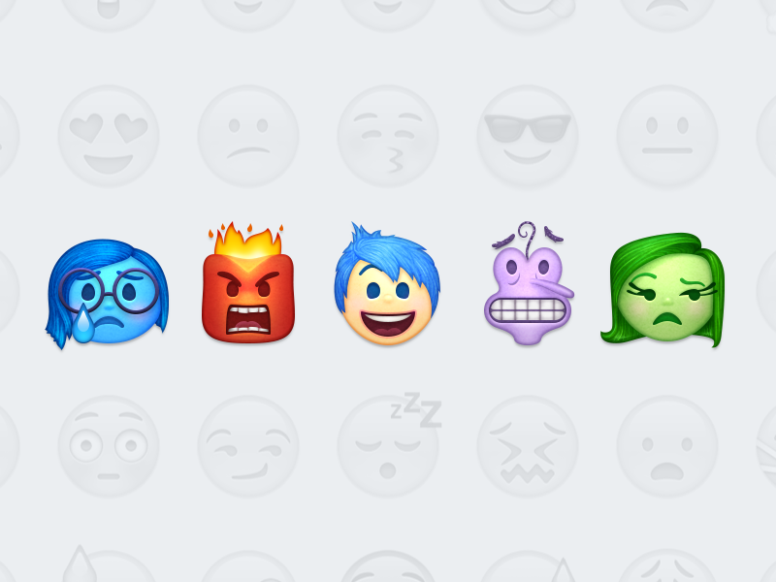

**Improvement / Cherry on top**

* Realtime
* Overlay with corresponding emoji/picture